**Low Level Design Document**

<<iRevatureTrainingRoomPlanner>>

iOS Mobile App Development Batch

Location : USF – NEC

Version: 1.0

Change History:

|  |  |  |  |
| --- | --- | --- | --- |
| Author | Date | Description | Reviewed by |
| Jeremy | 2/6/2020 | Created | Wesley |
|  |  |  |  |
|  |  |  |  |

**Contents**

1. Introduction
   1. Summary
   2. Development Information
   3. Compatibility
   4. Deployment
   5. Definitions
      1. Product Backlog
      2. Sprint Backlog
      3. Backend
2. Use Cases
3. Use Case Diagram
4. App Database Design
5. App Configurations
6. UI/UX Wireframes
7. Class Diagram
8. Component Diagram
9. Deployment Diagram
10. API Consumption

# Introduction

* 1. Summary

This project is a streamlined digital version of the room scheduling system currently in place at Revature locations. We aim to model the functionality of the current system in an easily accessible manner that is as scalable as it is convenient. The Mobile App we are developing will allow Batches to be assigned to available Rooms at various Locations with Trainers associated to the skill sets required for the Batch goals.

* 1. Development Information

|  |  |
| --- | --- |
| **Toolset/iPhone Model** | **Version** |
| XCode | 9.2 |
| Swift | 4.0 |
| iPhone | 6 - X |

* 1. Compatibility

This Mobile App aims to be compatible with all Apple iPhone 6 models or higher running iOS version 8.0 to 11.4.1

* 1. Deployment

This Mobile App will be deployed as a Pilot in the form of an iTunes Package called a .ipa file.

* 1. Definitions
     1. Product Backlog - The User Stories and Sub-task list for the entire project, including rough estimates and assignments.
     2. Sprint Backlog - The User Stories and Sub-task list for the current sprint. This project will be split into three sprints, each lasting 1 week.
     3. Backend - When Backend is referenced in this document or any other in relation to this project we are referring to the APIs provided which will supply information from the Backend. We will not be required to develop our own Backend systems.

# Use Cases

|  |  |
| --- | --- |
| **User Story** | **Use Case** |
| **As a user, I can authenticate my Revature credentials so I can use Training Director, Batch Manager, or Site Manager functions.** | Users (Actors) can log into the system with their various credentials. |
| **Once logged in, users can view all training rooms, batches, and trainers so they can schedule them.** | Actors can view all relevant information about their rooms, batches, and trainers. |
| **As a Training Director, Batch Manager, or Site Manager, I can schedule a room and batch and trainer combination.** | Actors can combine a set of Batch, Trainer, and Room components to create an assignment. |
| **As the system, I notify all involved parties with a Push Notification where necessary.** | Once an assignment is created, all authorized users are notified via Push Notification. |
|  | Relevant Actors who are not authorized will be notified when they log in. |
| **As the system, information is used from the device storage related to previous queries, unless a push notification says otherwise.** | The system will notify the App if changes have been applied from the database. The App will check for and download the new information the next time it is launched. |
|  | The system will use information stored on the device if no changes have been notified. |

# 

# Use Case Diagrams

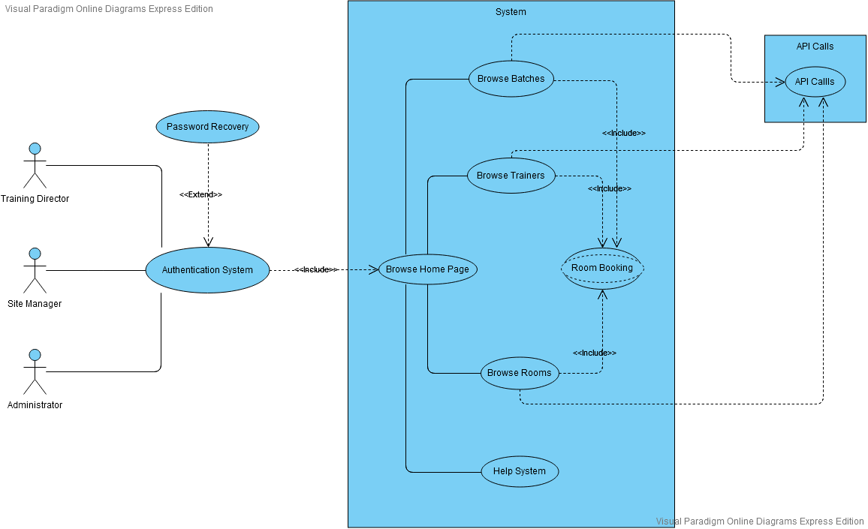

# App Database Design

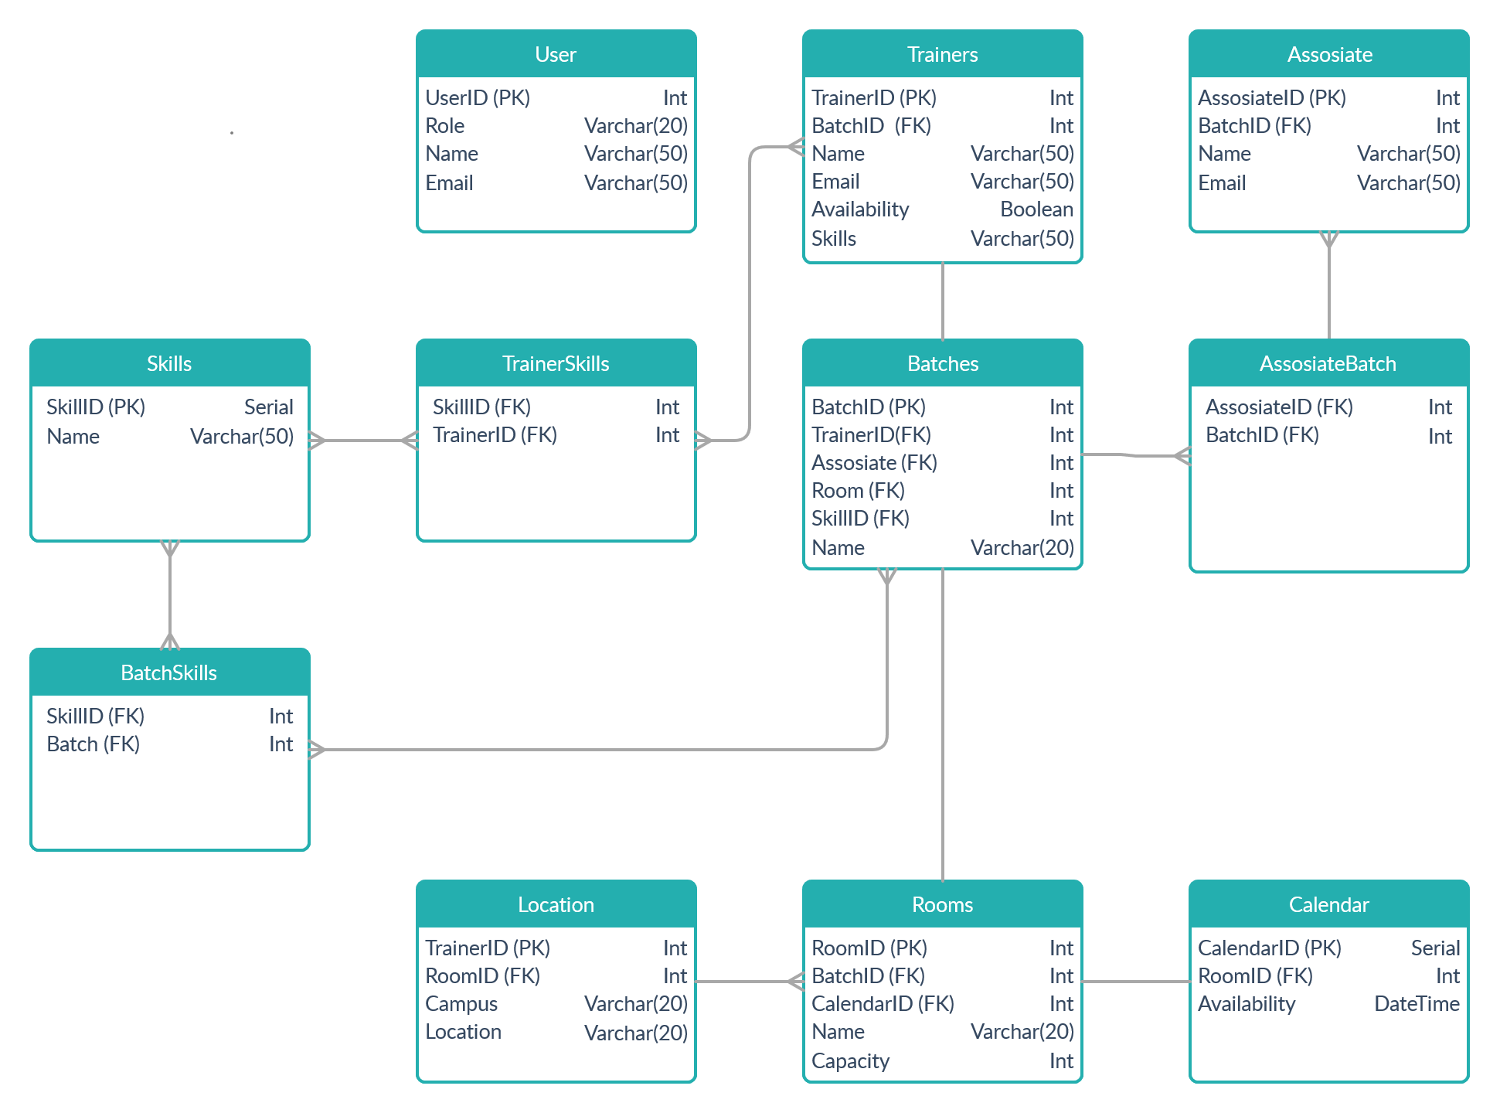

# App Configurations

# UI/UX Wireframes

* 1. Project Workflow Wireframe

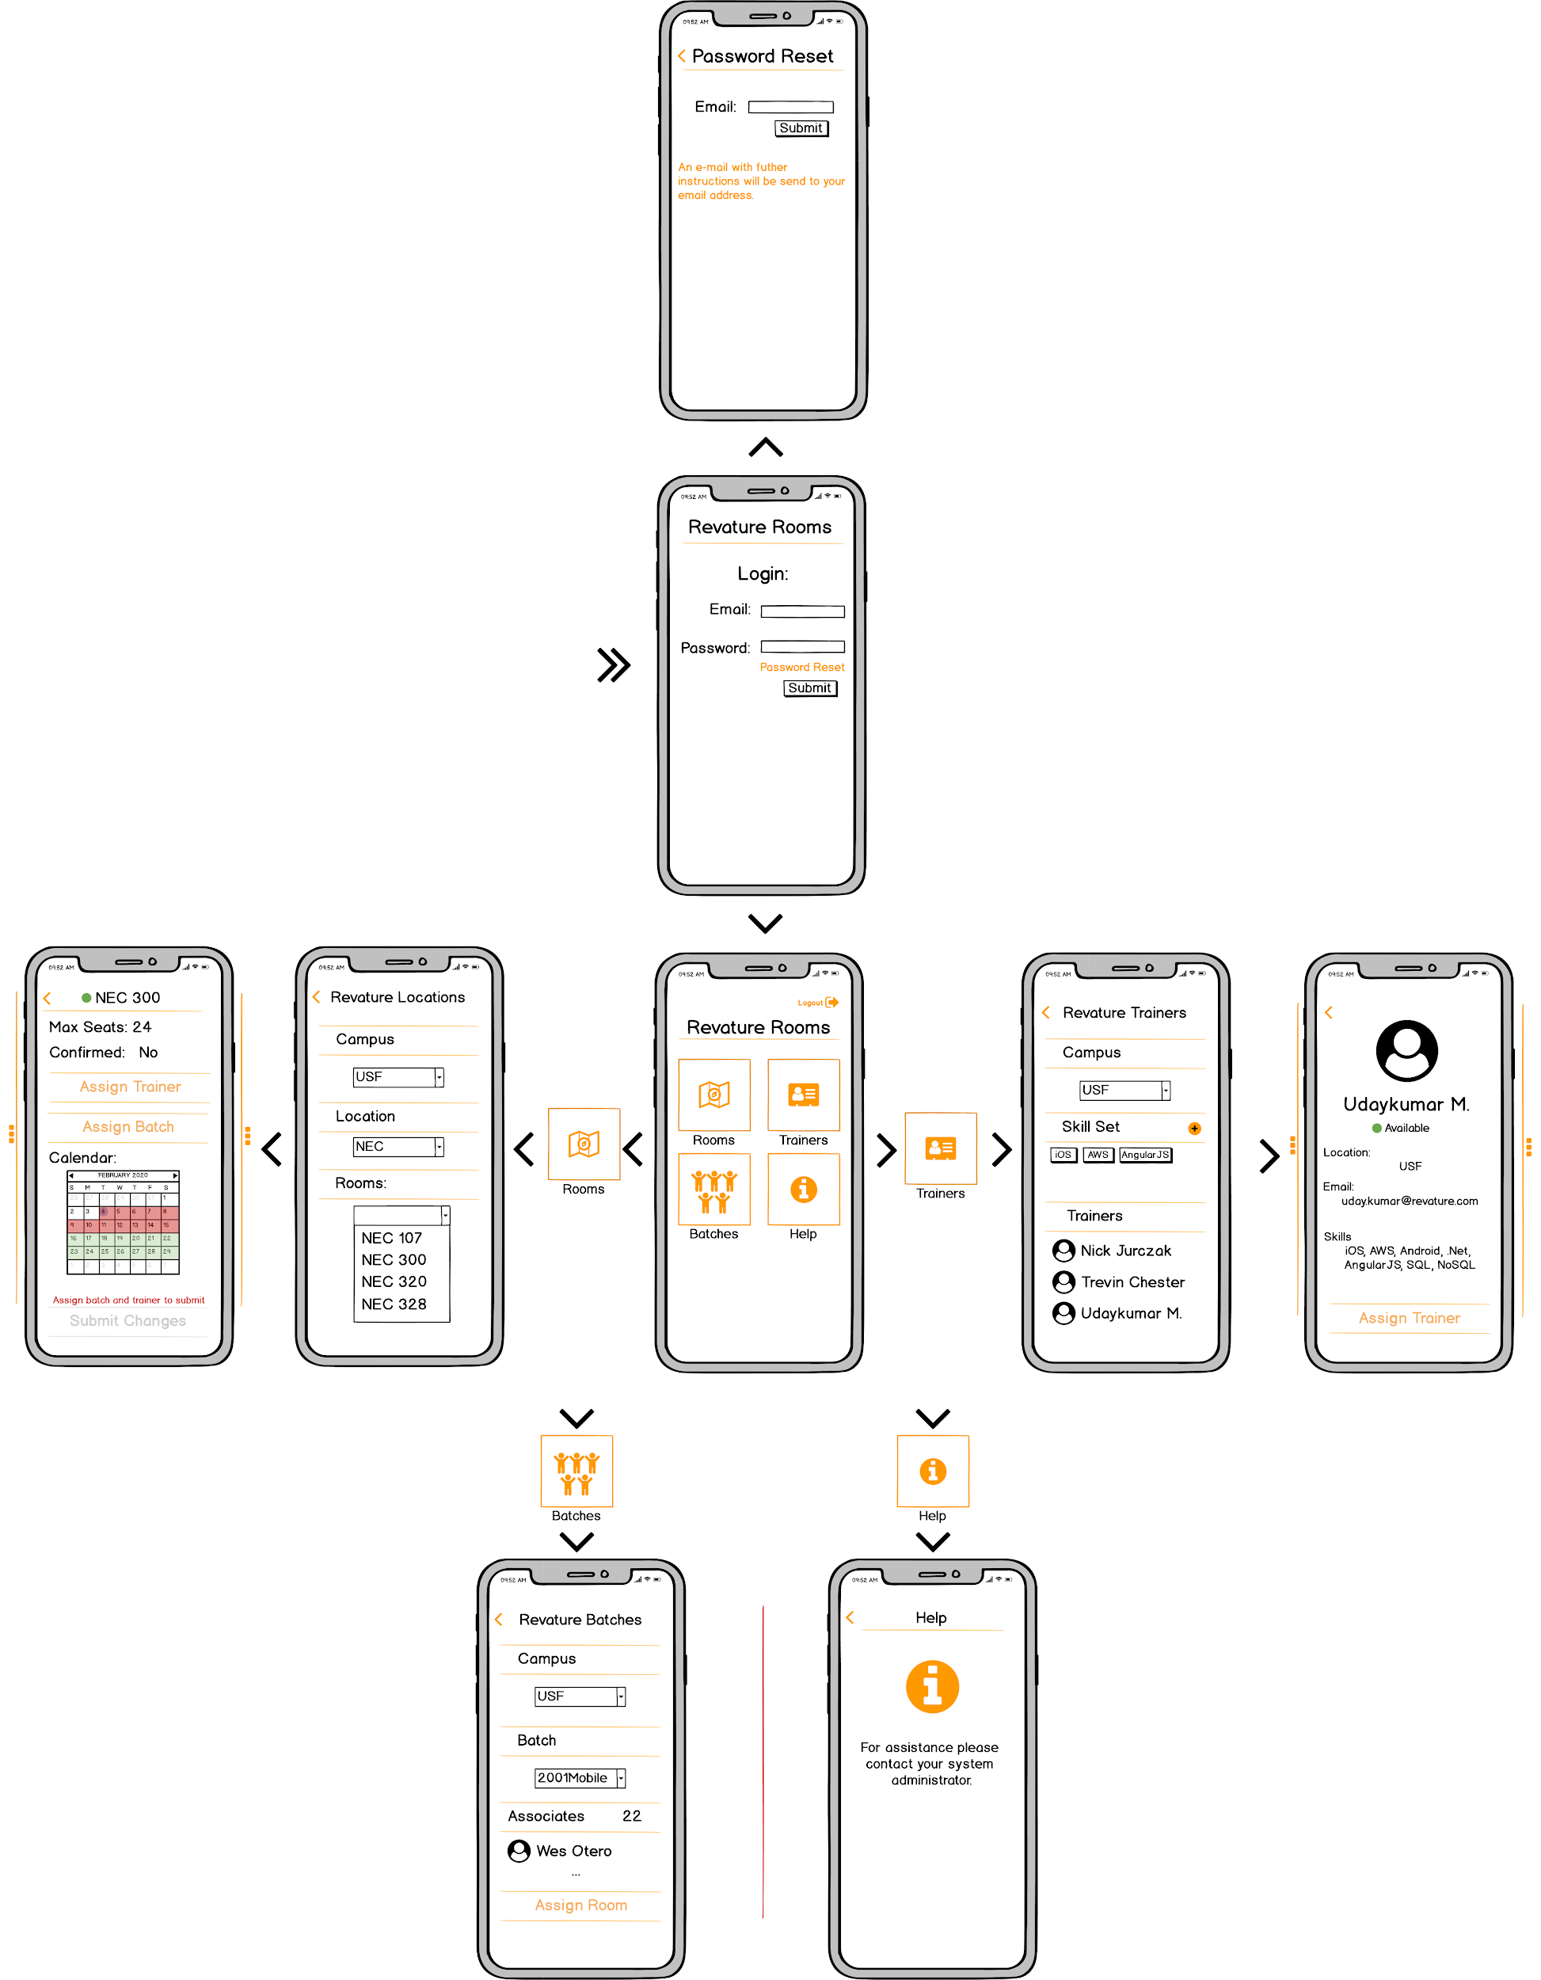

* 1. Batch Assignment Example Workflow

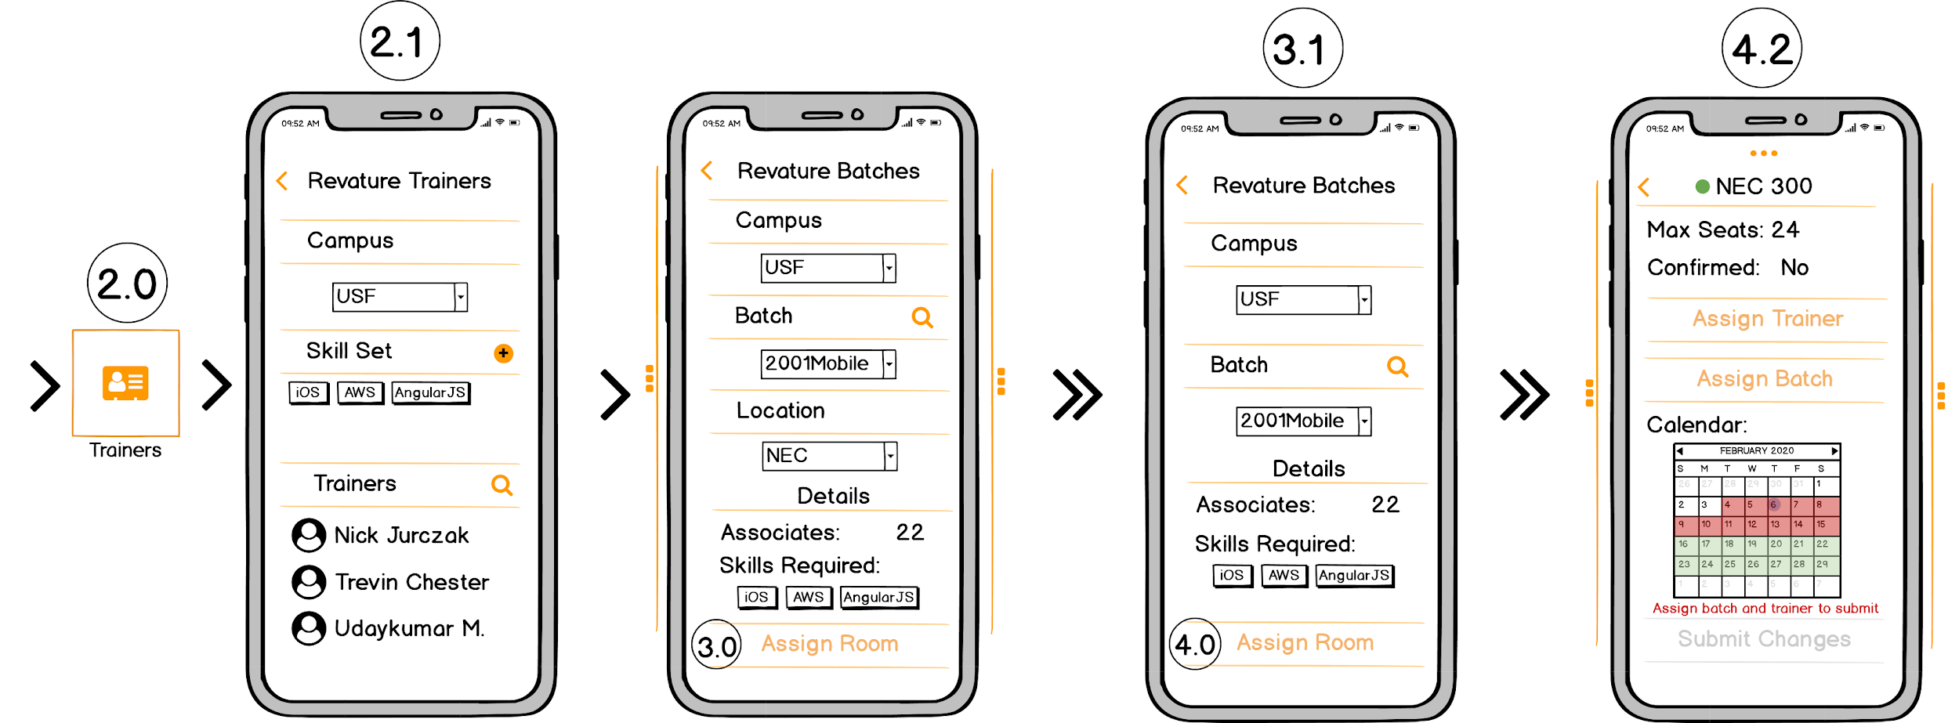

# Class Diagram

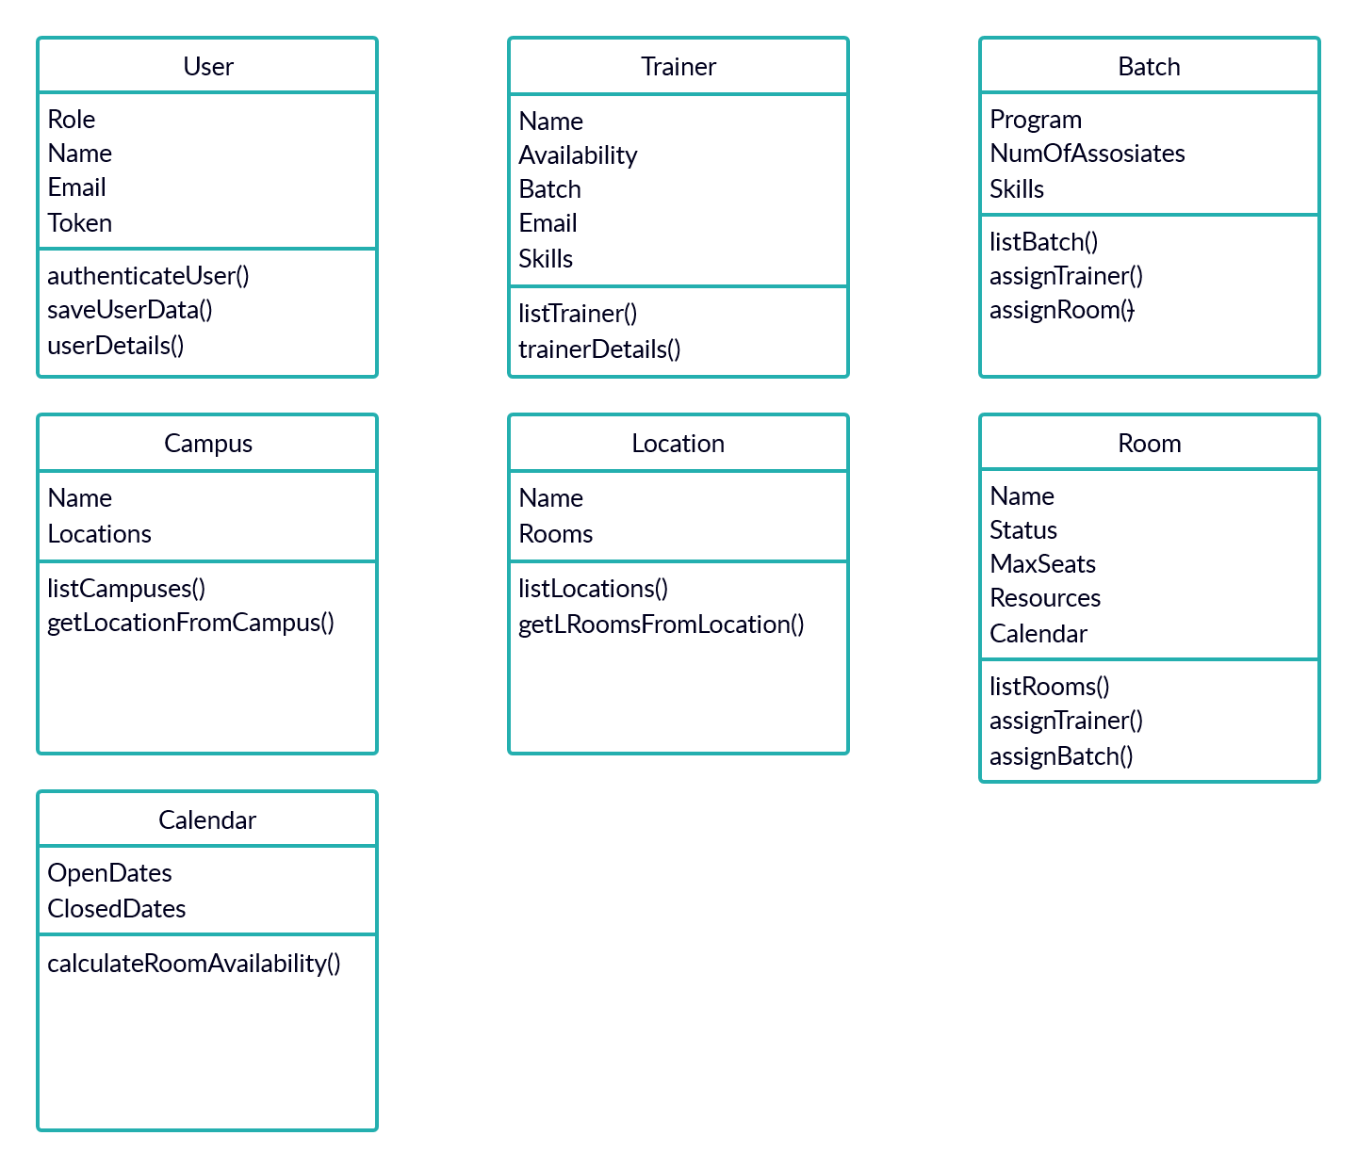

# Component Diagram

# Deployment Diagram

# API Consumption